 | Filing Reference : |  | GG/COMS/TS.2/17
 | Document Title : |  | Use-Case Realization Report (Analysis)  Start Cylinder Production Process
 | Version : |  | 1.0
 | Prepared By : |  | Koh Ming Jin
 | Date Created : |  | Monday, Apr 29th, 2011
Approved By :
 |  | Tran Ba Tien |  | Date
 |  | Project Manager |  | 29th Apr 2011
©2011 [Hoang Kim joint stock Company].
The information contained in this document is the property of [Hoang Kim joint stock Company]. The contents must not be reproduced, wholly or in part, for purposes other than for which it has been supplied, without the prior permission of [Hoang Kim joint stock Company], or, if it has been furnished under contract to another party, as expressly authorised under that contract. [Hoang Kim joint stock Company] shall not be liable for any errors or omissions.

Revision History
Date | Version | Description | Author
29/Apr/2011 | 1.0 | Initial Document | Koh Ming Jin

Table of Contents
1. Brief Description 4
2. Flow of Events 4
2.1 Standard Flow 4
2.1.1 Log-In 4
2.1.2 User Functions 4
2.1.3 Log-Out 4
2.2 Exception 4
3. Interaction Diagrams 5
3.1 Collaboration Diagram for Start Cylinder Production Process 5
4. Participating Objects 5
4.1 Main Page 5
4.2 Role Main Page 5
4.3 Main Controller 5
4.4 Cylinder Controller 5
4.5 Cylinder 5
5. Class Diagrams 6
5.1 Domain Class Diagram: Start Cylinder Production Process 6
6. Derived Requirements 6

Use-Case Realization Report
Start Cylinder Production Process

Brief Description
This use case enables an operation manager to start cylinder production process.

Flow of Events
The standard flow of events for this use case and any exceptions are described in the following subsections. See section 3.1 for an overview of the participating Actors and Domain Objects.

Standard Flow
The flow of events is described as follows:

Log-In
To commence using the system, the Operation Manager is required to log-in successfully as follows:
- Refer to Log In Use Case for details.

User Functions
- The use case starts when Operation Manager selects the Start Cylinder Production option of the system.
- The operation manager will input the Cylinder ID (keyboard/barcode scanner) into the system using the operation inputCylinderID.
- Once submitted, the RoleMainPage will call the startCylinderProd operation of the MainController.
- The MainController will call the startProduction operation of CylinderController and the CylinderController will update the Cylinder’s next step, by calling the operation updateCylinderNextStep.
- The Cylinder will be manually moved to the next process step.

Log-Out
- The Operation Manager will terminate use of COMS (ie: log-out) by pressing a button with the caption “Log Out”.
- Refer to the Log Out Use Case for details.

Exception
- Unable to start a process. The actor can only start a cylinder production process which is not running or has not been started before. The start button for any existing running process will be disabled.
- An error will be prompted to the user if the Cylinder’s next process step cannot be updated.

Interaction Diagrams

Collaboration Diagram for Start Cylinder Production Process
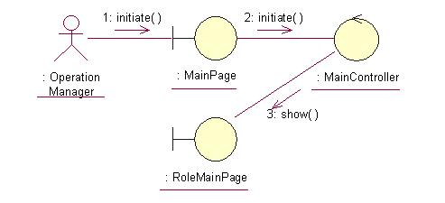
The above collaboration diagram shows the process flow after the actor has login.

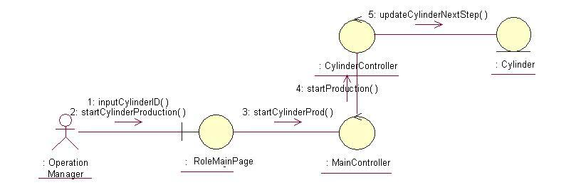
The above collaboration diagram shows the main process flow of this use case.

Participating Objects

Operation Manager
This actor represents the operation manager who will have a web page console to monitor and update the cylinder manufacturing operation.

Main Page
This object renders the contents after the actor has login. The Director, Department Manager and Operation Manager actors use this object.

Role Main Page
This object renders the contents (based on the user role) after the actor has login. The Director, Department Manager and Operation Manager actors use this object.

Main Controller
This object acts as the middleman between Role Main Page and the Error Controller. It will translate interactions with the view into actions to be performed by the Error Controller.

Cylinder Controller
This object acts as the middleman between “Start Cylinder Production” Page and the Cylinder object. It will translate interactions with the view into actions to be performed by the Cylinder object.

Cylinder
This object stores the details concerning the cylinder information of the COMS.

Class Diagrams

Domain Class Diagram: Start Cylinder Production Process
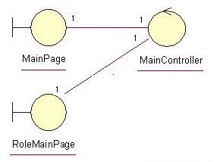
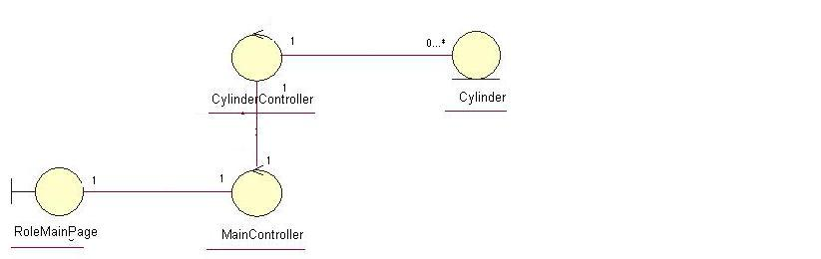

Derived Requirements
The Operation Manager PC keyboard and mouse or barcode scanner will be used to enter cylinder production process information details (if any) and view all the system responses.

